**Use case List:**

| **Primary Actor** | **Use Cases** |
| --- | --- |
| DOCTOR | 1. Add patient’s record  2. Update patient’s record  3. Provide available time to CMS make an appointment |
| NURSE | 4. Create replace patient’s appointment  5. Manage patient’s appointment  6. Manage patient’s medicine order |
| PATIENT | 7. Make an appointment online  8. Cancel an appointment  9. Order medicine via online service |

**Use case Diagram:**

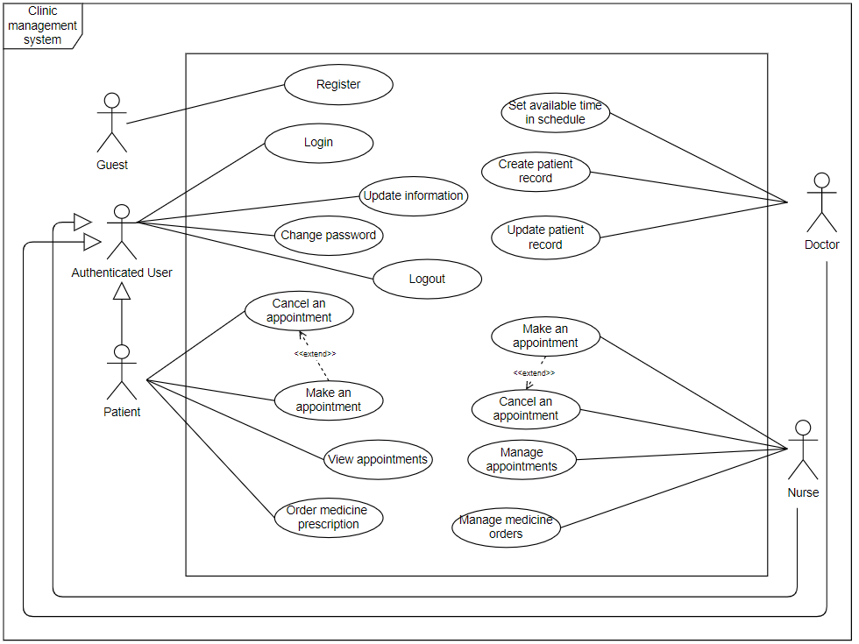

**Use case specification:**

| ID and Name: | **UC-1 Add Patient Record** | | |
| --- | --- | --- | --- |
| Created By: | Phạm Vĩnh Nhân |  | 23/09/2021 |
| Primary Actor: | Doctor |  |  |
| Description: | Doctor access to the clinic system via the internet, view the patient’s information and add new record | | |
| Trigger: | When doctors need to update the patient’s record after reviewing the treatment | | |
| Preconditions: | PRE-1. The doctor must log in to the Online Clinic System with the doctor role.  PRE-2. The patient must have information in the system | | |
| Postconditions: | POST-1. The new patient record has been added to the database  POST-2. The doctor appointment status is updated to complete | | |
| Normal Flow: | **1.0 Add patient record**   1. Doctor needs to add the patient record after treatment. 2. Doctor log in with their account and view the information of all users in the system 3. Doctor enters the name, or phone of the patient, and click to search 4. Doctor opens “add patient record form” 5. Doctor enters new information, and click the save button 6. System displays the success message or failed message to the form | | |
| Alternative Flows: | **1. Doctor cancel add record**   1. Doctor click on the cancel button 2. Return to the patient list   **2. Invalid input**   1. The system will display the alert and request doctor re-input 2. Return to step 3 in normal flow | | |
| Exceptions: | **1. The patient is not exist**   1. The system displays an error message to the user 2. The system redirects the user to find patients page 3. Return to step 3 to enter patient information again | | |

| ID and Name: | **UC-2 Update Patient Record** | | |
| --- | --- | --- | --- |
| Created By: | Nguyen Thai Thinh | Date Created | 23/09/2021 |
| Primary Actor: | Doctors |  |  |
| Description: | Doctor access to the clinic system via the internet, view the patient’s record and add new record | | |
| Trigger: | When the patients come to get medical treatment | | |
| Preconditions: | PRE-1. The doctor must log in to the Online Clinic System with the doctor role.  PRE-2. The patient’s record is added by the same doctor | | |
| Postconditions: | POST-1. The patient’s record is updated to the database | | |
| Normal Flow: | **1.0 Update patient’s record**   1. Doctor enters the name, or phone of the user, and click to Update Record 2. Nurse opens “Update patient’s record form” 3. Doctors enter an update of a patient's health condition in record 4. Doctor either click confirm or cancel update 5. System displays the success message, or failed message to the form | | |
| Alternative Flows: | **1. Doctor cancel update information**   1. Doctor click to the cancel button at step 5 in normal flow 2. System display back to the original record | | |
| Exceptions: | **1. The record not found**   1. The system displays an error message to the user 2. The system redirects the user to find records page 3. Return at step 1 in normal flow to input again patient’s record or create new record | | |

| ID and Name: | **UC-3 Provide available time to CMS make an appointment** | | |
| --- | --- | --- | --- |
| Created By: | Truong Binh Tan | Date Created | 24/09/2021 |
| Primary Actor: | Doctor |  |  |
| Description: | A doctor accesses the CMS and updates the list of doctor’s available times for the patient. | | |
| Trigger: | When a doctor change his timeline or he has new available time | | |
| Preconditions: | PRE-1. The doctor is logged into CMS with an account for the doctor  PRE-2. Access doctor’s available time management. | | |
| Postconditions: | POST-1. The doctor’s schedule time is updated to the database  POST-2 Nurse should be notified of the new update | | |
| Normal Flow: | **1.0 Provide available time to CMS make an appointment**   1. The doctor login as a doctor role into CMS. 2. Access to list of doctor’s available time 3. Doctors have to update doctor’s available time for patients. 4. CMS displays menu doctor’s available time. 5. The doctor fills available time to the list. 6. CMS displays success messages. | | |
| Alternative Flows: | **1. The doctor updates their available time.**   1. CMS updates doctor’s available time of the patient. 2. CMS displays update success. | | |
| Exceptions: | **1.0.E1 Provide time in the invalid time**   1. The system displays an error message to the user 2. Return at step 5 in normal flow for user to enter input again | | |

| ID and Name: | **UC-4 Create replace patient appointment online** | | |
| --- | --- | --- | --- |
| Created By: | Thái Thịnh | Date Created | 23/09/2021 |
| Primary Actor: | Nurses |  |  |
| Description: | A Nurse accesses the CMS through the internet, adds a patient appointment when a doctor changes his timeline and nurses have to change doctor for a patient appointment. | | |
| Trigger: | When doctor can’t make appointment that their assigned | | |
| Preconditions: | PRE-1. Nurses must log in to the Online Clinic System.  PRE-2. The patient is an exited user in the system | | |
| Postconditions: | POST-1. New patient’s appointments will be updated in the database.  POST-2. CMS sends patients new appointments. | | |
| Normal Flow: | **1.0 Add a patient information**   1. Nurse will input the appointment's information. 2. The CMS will validate if this patient’s appointment is valid or not. 3. CMS displays new patient’s appointments. 4. Nurse either confirms the appointment(continues normal flow) or modifies the appointment. 5. Nurse confirms the new patient’s appointment. 6. CMS saves the time a new patient’s appointment was added on. 7. CMS sends a success message confirming the new patient’s appointment. | | |
| Alternative Flows: | **1. Add multiple patient’s appointments**   1. Nurse inputs a specified number of patients. Return to step 2 of normal flow. | | |
| Exceptions: | **1. Patient appointments are already in the database.**   1. The system displays an error message to the user 2. Return at step 2 in normal flow for the user to enter input again | | |

| ID and Name: | **UC-5 Manage patient’s appointment** | | |
| --- | --- | --- | --- |
| Created By: | Thái Thịnh | Date Created | 23/09/2021 |
| Primary Actor: | Nurse |  |  |
| Description: | Nurse manages the clinic’s appointment information such as the total appointment, time appointment to create notification for doctors. | | |
| Trigger: | Nurse wants to manage the clinic’s appointment information | | |
| Preconditions: | PRE-1. Nurse is logged as a nurse role into the CMS.  PRE-2. Nurse accesses the clinic’s appointment page | | |
| Postconditions: | POST-1: Export the clinic’s order information as PDF, XLSX, XLS, ... | | |
| Normal Flow: | **1. View the patient’s appointment information**   1. Nurse views all the patient’s appointment information 2. CMS display all the patient’s appointment information 3. Nurse searches the patient’s appointment information base on their needs 4. CMS display patient’s appointment information the nurse’s need | | |

| ID and Name: | **UC-6 Manage patient’s medicine order** | | |
| --- | --- | --- | --- |
| Created By: | Cao Chi Hai | Date Created | 23/09/2021 |
| Primary Actor: | Nurse |  |  |
| Description: | Nurse manages the clinic’s order information such as revenue, profit, ... | | |
| Trigger: | Nurse wants to create orders statistics | | |
| Preconditions: | PRE-1. Nurse is logged as a nurse role into the CMS | | |
| Postconditions: | POST-1: Export the clinic’s order information as PDF, XLSX, XLS, ... | | |
| Normal Flow: | **1. View the clinic’s orders information**   1. Nurse views all the clinic’s order information 2. CMS display all the clinic’s order information 3. Nurse searches the clinic’s order information base on their needs 4. CMS display information base the nurse’s need   **2. Export information**   1. Nurse chooses type of export file 2. CMS exports the clinic’s information as the type that nurse chose | | |
| Alternative Flows: |  | | |
| Exceptions: | **1. No data existed**   * CMS must display a message to notificate the nurse that there are not data | | |

| ID and Name: | **UC-7 Make an appointment** | | |
| --- | --- | --- | --- |
| Created By: | Thái Thịnh |  |  |
| Primary Actor: | Patients |  |  |
| Description: | A Patient accesses the Clinic System through the internet, views the doctor available for appointment, selects doctor, and chooses time for an appointment.. | | |
| Trigger: | A patient indicates that he wants to make an appointment | | |
| Preconditions: | PRE-1. Patient is logged into the CMS.  PRE-2. Patient booking an available doctor. | | |
| Postconditions: | POST-1. The doctor status after the patient makes an appointment changes to “Not Available”.  POST-2. The appointment detail will send to the doctor that assigned  POST-3. Doctor's schedule will be updated. | | |
| Normal Flow: | **1. Make an appointment**   1. Patients view the doctor schedule for a specific date. (see 1.0.E1, 1.0.E2) 2. CMS displays a schedule of available doctors. 3. Patients choose a specific appointment. 4. CMS displays appointment times and location. 5. Patient either confirms the appointment (continues normal flow) or requests to modify the appointment. 6. Patient confirms the appointment. 7. CMS confirms acceptance of the appointment. 8. CMS sends Patient a message confirming appointment details and instructions. 9. CMS stores appointment records, sends information to assign doctors, and updates the doctor's schedule. | | |
| Alternative Flows: | **1. Make multiple appointment**   1. Patient requests a specified number of appointments. Return to step 1 of normal flow.   **2. Patient cancel appointment**   1. Patient asks to cancel the appointment. 2. Return to step 5 of normal flow. | | |
| Exceptions: | **1. No available doctor left**   1. CMS display message that there is no available doctor to make an appointment 2. Send patent a message when doctor available | | |

| ID and Name: | **UC-8 Cancel an appointment** | | |
| --- | --- | --- | --- |
| Created By: | Thái Thịnh | Date Created | 23/09/2021 |
| Primary Actor: | Patients |  |  |
| Description: | A Patient accesses the Clinic System through the internet, cancelling the appointment. | | |
| Trigger: | A patient can’t make an appointment in the appointment date | | |
| Preconditions: | PRE-1. Patients must cancel the appointment one day before the appointment date.  PRE-2. Patient gives the reason why they cancel the appointment. | | |
| Postconditions: | POST-1. The doctor status after the patient cancels an appointment changes to “Available”.  POST-2. The appointment cancel detail will send to the doctor that assigned  POST-3. Doctor's schedule will be updated. | | |
| Normal Flow: | **1. Cancel an appointment**   1. Patients view all the appointments for a specific date. 2. Patients choose a specific appointment. 3. CMS displays appointment times and location. 4. Patient request cancel the appointment 5. CMS accepted the cancellation of the appointment. 6. CMS sends the Patient a message confirming cancellation of an appointment. 7. CMS sends information to assign doctors, and updates the doctor's schedule. | | |
| Alternative Flows: | **1. Cancel multiple appointment**   1. Return to step 2 of normal flow | | |
| Exceptions: | **1. Patient can’t cancel appointment**   1. CMS informs the patient that there late to cancel appointment 2. Return to step 3 in normal flow | | |

| ID and Name: | **UC-9 Order medicine via online service** | | |
| --- | --- | --- | --- |
| Created By: | Truong Binh Tan | Date Created | 23/09/2021 |
| Primary Actor: | Patient |  |  |
| Description: | A patient accesses the CMS, filling the order medicine form. After that, the CMS will send medicine back to patient | | |
| Trigger: | When the patient need to buy more medicine | | |
| Preconditions: | PRE-1. The patient is logged into CMS with an account for the patient  PRE-2. Access order medicine service. | | |
| Postconditions: | POST-1. The order status after the patient makes an order changes to “Waiting”.  POST-2. The order detail will send to the nurse of CMS  POST-3. The nurse will send medicine to the patient | | |
| Normal Flow: | **1. Order medicine via online service**   1. The patients using their account login to CMS 2. Access the order medicine service and fill doctor’s prescription form 3. The patient clicks the send form button. 4. CMS sends a notification for the nurse. 5. CMS create the order with status “Waiting” 6. CMS displays order success. | | |
| Alternative Flows: | **1. Doctor’s prescription not found**   1. MSS send prescription not found notification. 2. Return to step 2 of normal flow | | |
| Exceptions: | **1. The clinic run out of required medicine**   1. Display out of stock message. 2. CMS will send patients a message when the medicine is available. | | |